

[**E-retail factors for customer activation**](https://www.researchgate.net/publication/346412647_E-retail_factors_for_customer_activation_and_retention_An_empirical_study_from_Indian_e-commerce_customers)[**and retention: A case study from Indian**](https://www.researchgate.net/publication/346412647_E-retail_factors_for_customer_activation_and_retention_An_empirical_study_from_Indian_e-commerce_customers)[**e-commerce customers**](https://www.researchgate.net/publication/346412647_E-retail_factors_for_customer_activation_and_retention_An_empirical_study_from_Indian_e-commerce_customers)

Submitted by:

VAISHALI SHUKLA

# ACKNOWLEDGMENT

I have taken efforts in this project. However, it would not have been possible without the kind support and help of many individuals and organizations. I would like to extend my sincere thanks to all of them.

I am highly indebted to Flip Robo Technologies Bangalore for their guidance and constant supervision as well as for providing necessary information regarding the project & also for their support in completing the project.

I want to thank my SME Mr. Shubham Yadav for providing the Dataset and helping us to solve the problem and addressing out our Query in right time.

I would like to express my gratitude towards my parents & members of Flip Robo for their kind co-operation and encouragement which help me in completion of this project.

I would like to express my special gratitude and thanks to industry persons for giving me such attention and time.

# INTRODUCTION

Customer satisfaction has emerged as one of the most important factors that guarantee the success of online store; it has been posited as a key stimulant of purchase, repurchase intentions and customer loyalty. A comprehensive review of the literature, theories and models have been carried out to propose the models for customer activation and customer retention.

Five major factors that contributed to the success of an e-commerce store have been identified as: service quality, system quality, information quality, trust and net benefit. The research furthermore investigated the factors that influence the online customers repeat purchase intention. The combination of both utilitarian value and hedonistic values are needed to affect the repeat purchase intention (loyalty) positively.

# Conceptual Background of the Domain Problem

The data is collected from the Indian online shoppers. Results indicate the e-retail success factors, which are very much critical for customer satisfaction.

Five major factors that contributed to the success of an e-commerce store have been identified as: service quality, system quality, information quality, trust and net benefit. The research furthermore investigated the factors that influence the online customers repeat purchase intention.

# Motivation for the Problem Undertaken

Our main objective of doing this project is to analyse whether the users are shopping products from e-commerce websites, how did they give feedbacks to these websites on the basis of several positive and negative factors and also the details of the users on basis of factors like age, gender, etc.

# Diagrammatic Representation of Customer Retention

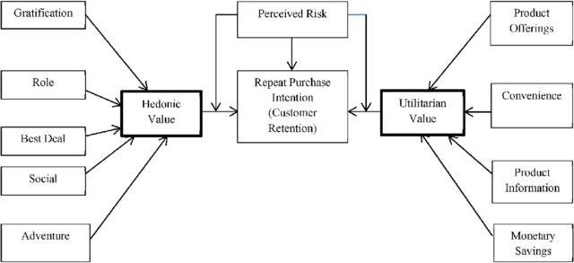

The Hedonic value consists of factors like Gratification, Role, Best Deal, Social and Adventure.

The Utilitarian value consists of factors like Product Offerings, Convenience, Product Information and Monetary Savings.

Customer Retention is based on 3 factors, according to the above diagram. They are:

Perceived Risk, Hedonic value and Utilitarian value

# Data Sources and their formats

The data is been given by a highly-confidential company and they gave it to us in an excel file. They also had provided the problem statement by explaining what they need from us and also the required criteria to be satisfied.

Let’s check the data now. Below I have attached the snapshot below to give an overview.

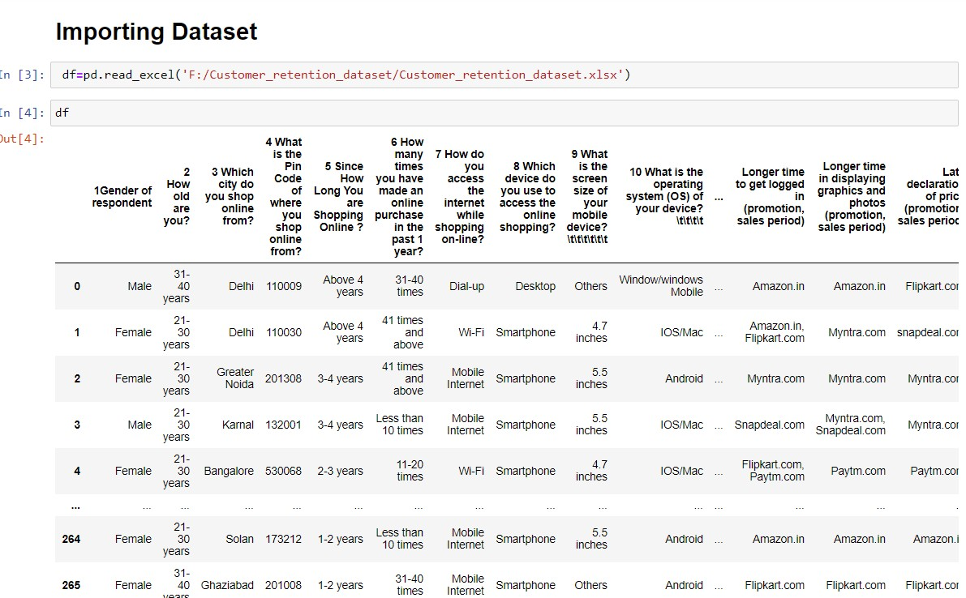

-> There are totally 269 rows and 71 columns in this dataset

-> Our objective is to find the insights of the data and to do data analysis.

# Hardware and Software Requirements and Tools Used

For doing this project, the hardware used is a laptop with high end specification and a stable internet connection. While coming to software part, I had used anaconda navigator and in that I have used **Jupyter notebook** to do my python programming and analysis.

For using an excel file, Microsoft excel is needed. In Jupyter notebook, I had used lots of python libraries to carry out this project and I have mentioned below with proper justification:

1. Pandas- a library which is used to read the data, visualisation and analysis of data.
2. NumPy- used for working with array and various mathematical techniques.
3. Seaborn- visualization tool for plotting different types of plot.
4. Matplotlib- It provides an object-oriented API for embedding plots into applications.

# Data Analysis

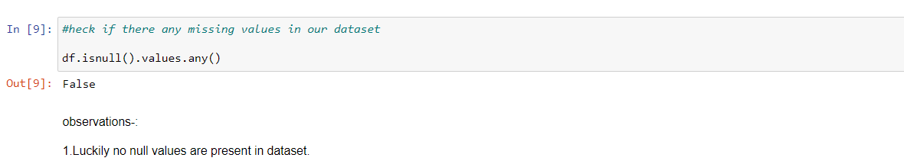

There are no null values in this dataset and 70 columns are of object datatype and only 1 column is of int64 data type.

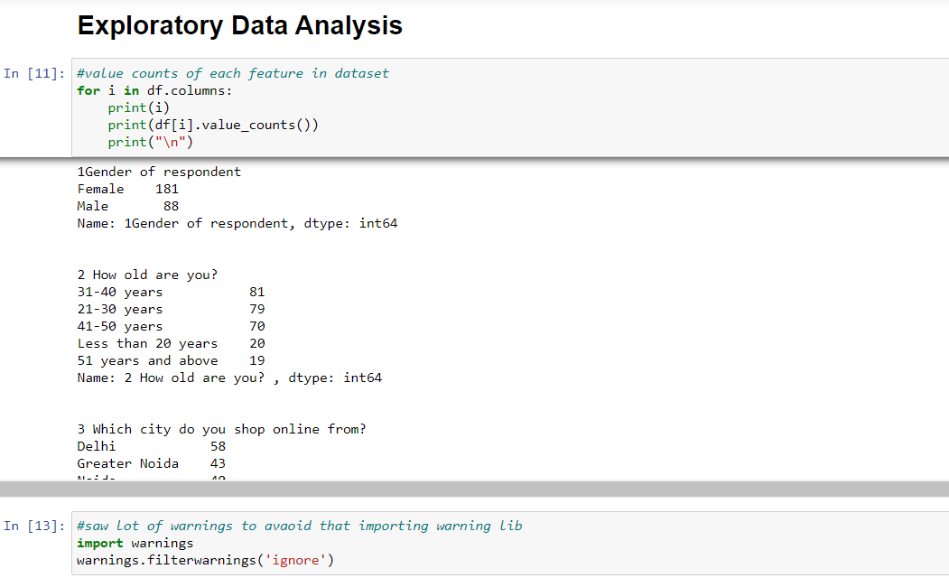

We checked the value counts of all 71 columns above and we iterated using a for loop. We can see some value counts of the columns like gender, age, city, etc. Below I had attached the value counts of other columns.

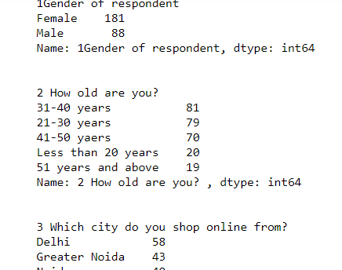

# Analysis of website feedbacks obtained

We can see that after column 47, there are both positive and negative feedbacks of the websites, which are given by the correspondents. We will analyse those data by using data analysis process.

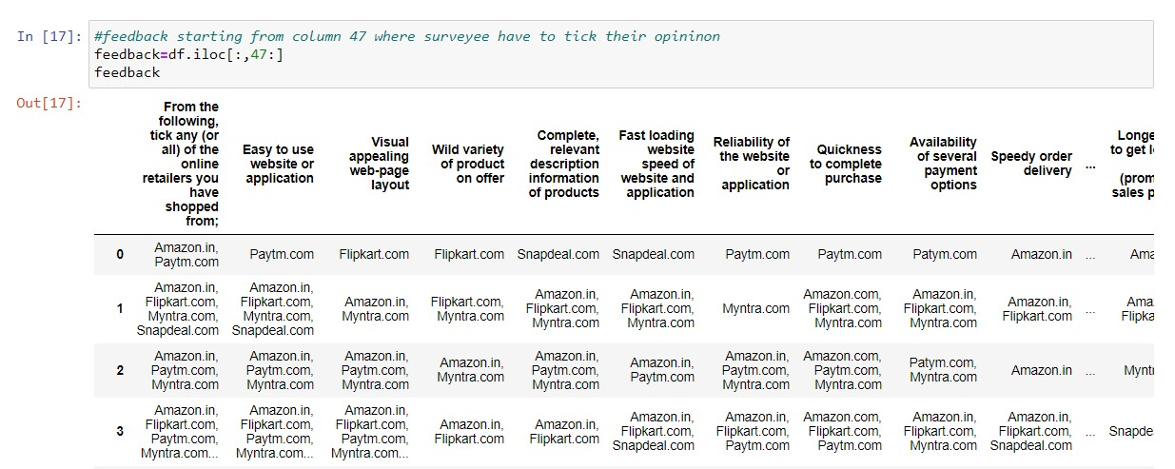

First, we will extract only the feedbacks data and then save it in a new data frame, which will be used for further process.

#A separate dataframe for displaying the positive feedback

dfpf=feedback.drop(["Longer time to get logged in (promotion, sales period)",

"Longer time in displaying graphics and photos (promotion, sales period)",

"Late declaration of price (promotion, sales period)", "Longer page loading time (promotion, sales period)", "Limited mode of payment on most products (promotion,

sales period)",

"Longer delivery period", "Frequent disruption when moving from one page to another"], axis=1)

# A separate dataframe for displaying the negative feedback

dfnf=feedback[["Longer time to get logged in (promotion, sales period)",

"Longer time in displaying graphics and photos (promotion, sales period)",

"Late declaration of price (promotion, sales period)", "Longer page loading time (promotion, sales period)",

"Limited mode of payment on most products (promotion, sales period)",

"Longer delivery period", "Frequent disruption when moving from one page to another"]]

Now, we will analyse the negative and positive feedbacks first by checking the count of websites and the type of feedbacks given to each website. Then, we will save the obtained data in a new data frame and rename the column names.

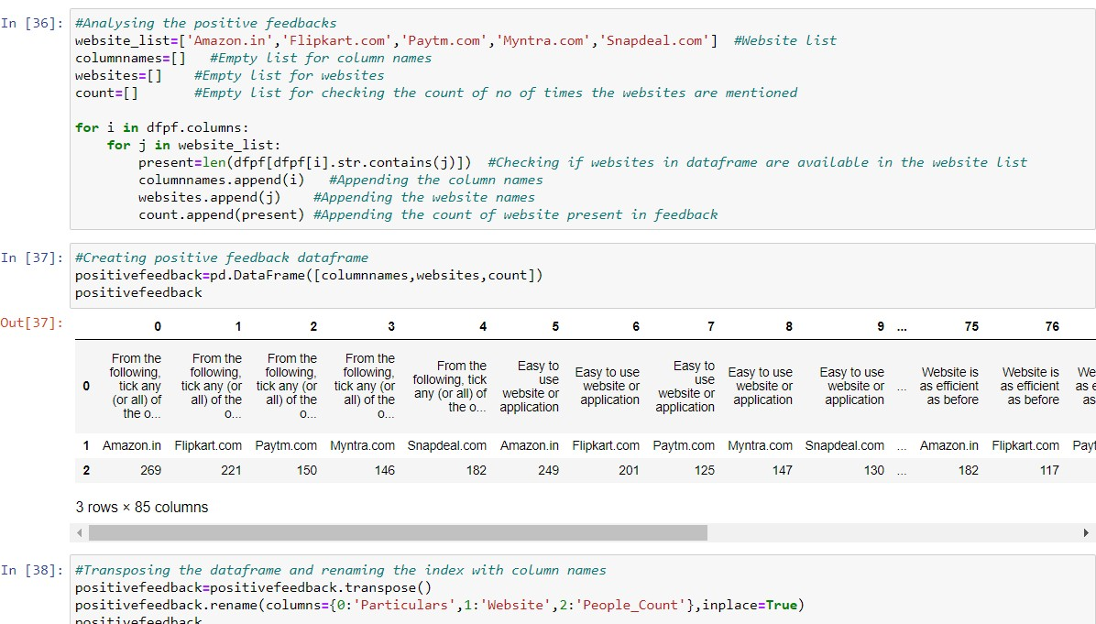

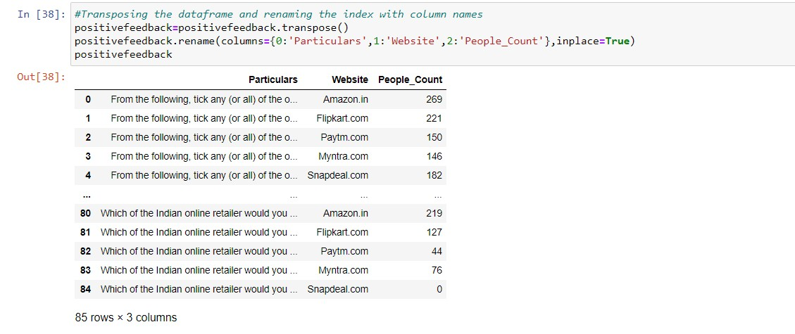

About negative feedbacks

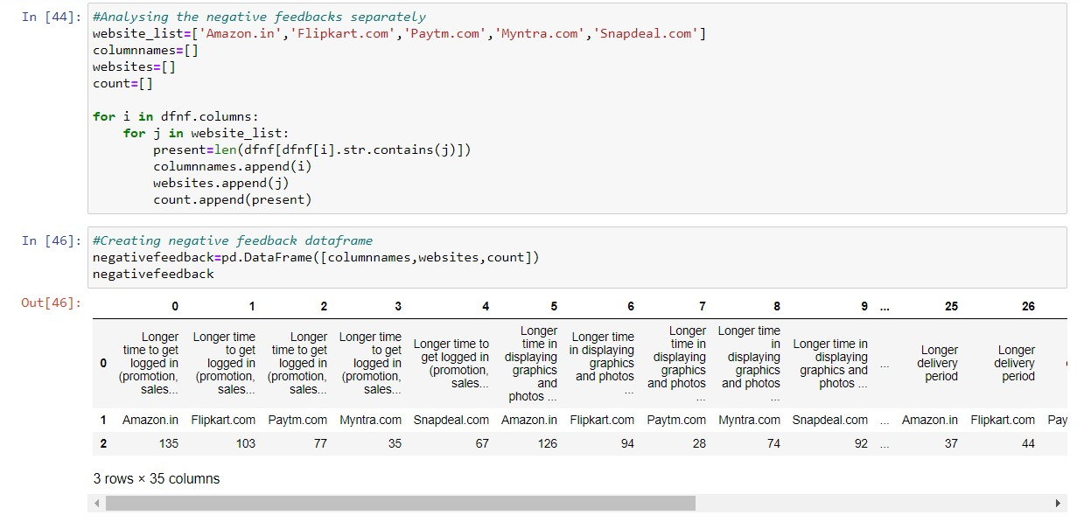

# Calculating the percentage wise feedback analysis

Now, we will calculate the percentage of people giving the feedbacks to the website for both positive and negative data

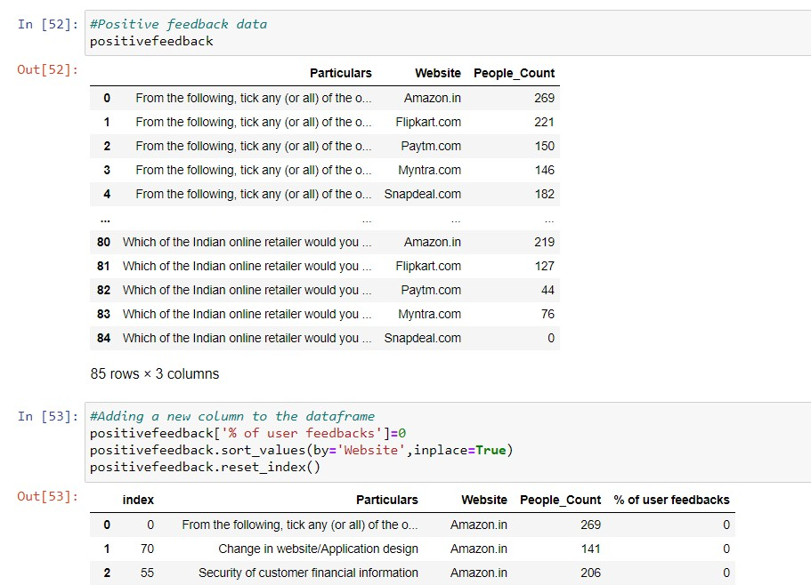

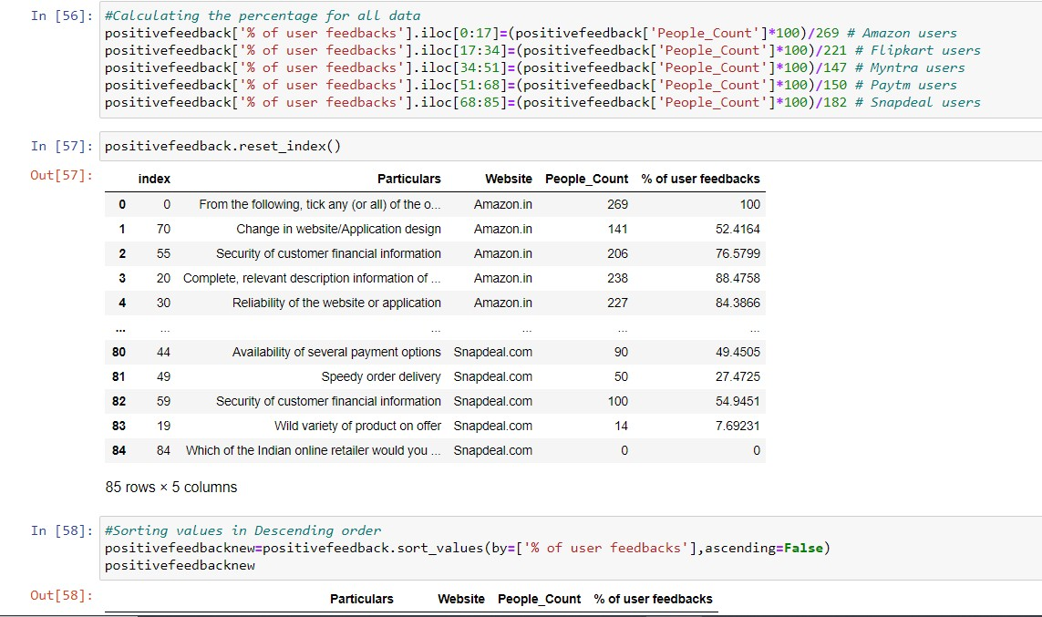

# Observations:

* 1. Amazon and Flipkart rank about 90% in satisfying customers, followed by Myntra.
  2. The maximum percentage Paytm and Snapdeal could score here is 83 and 71 respectively.
  3. Noone choose to refer Snapdeal to their contacts as it has the less percentage among all websites.
  4. On an average, Snapdeal and Paytm scores are less when compared to amazon, flipkart and Myntra.

**For negative:**

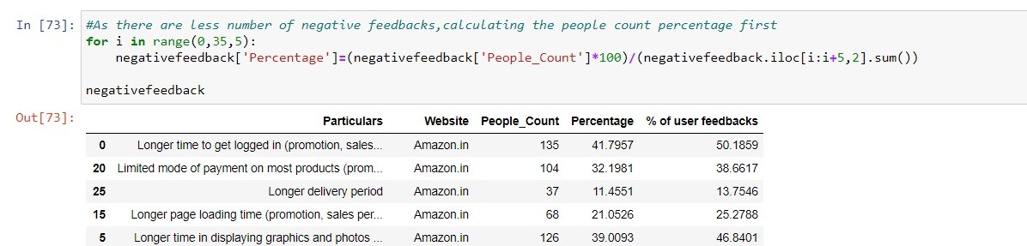

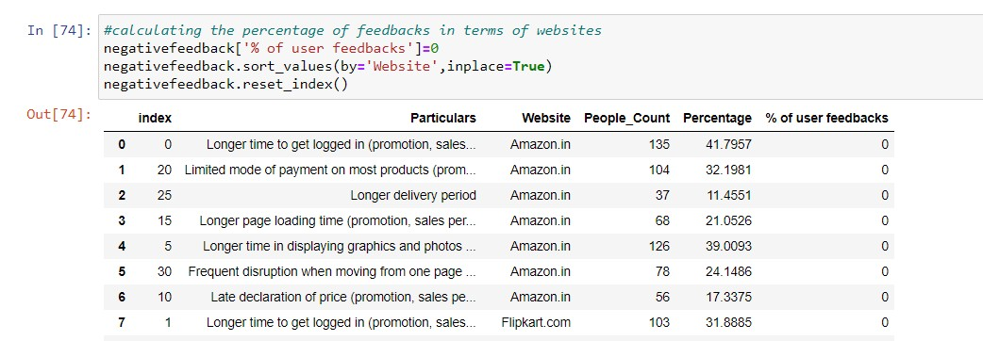

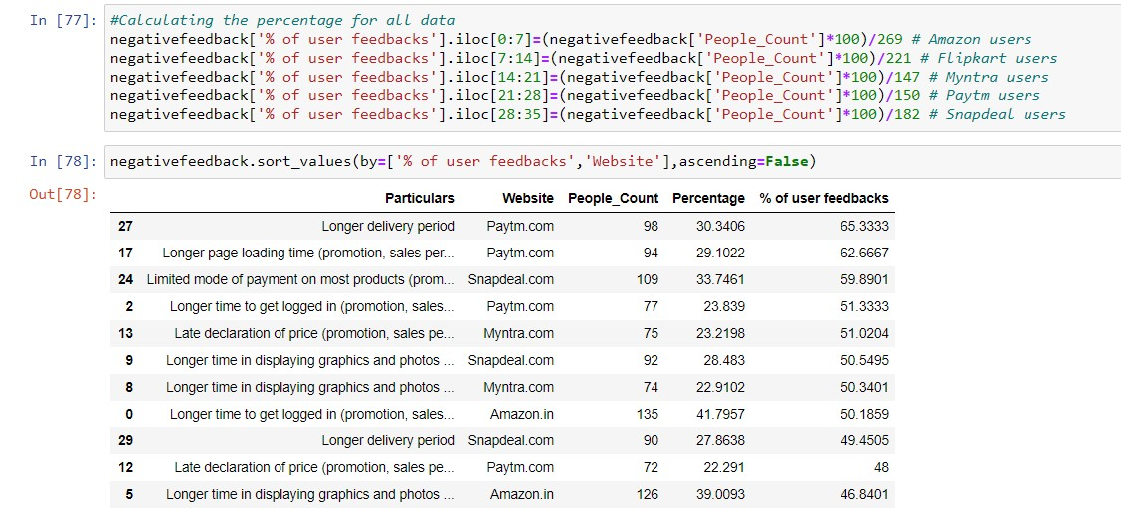

# Observations:

1. Around 65% of Paytm customers are not happy with their delivery period and longer term in loading pages.
2. Approx. 60% of Snapdeal customers are not happy about their limited mode of payment and nearly 50% of people are not satisfied in longer time of displaying graphics.
3. We can observe that even though with count wise, Amazon and Flipkart showed more negative reviews. When we take percentage, in top 10, Amazon has appeared only once and flipkart has not even appeared even one time.
4. The highest percentage Myntra got is 51, whereas flipkart's highest percentage is 46. However, other websites like Paytm, snapdeal.com have got highest percentage for negative reviews around 60-67%.
5. In terms of less dissatisfaction, myntra.com and flipkart are better, followed by amazon.

# Visualizations

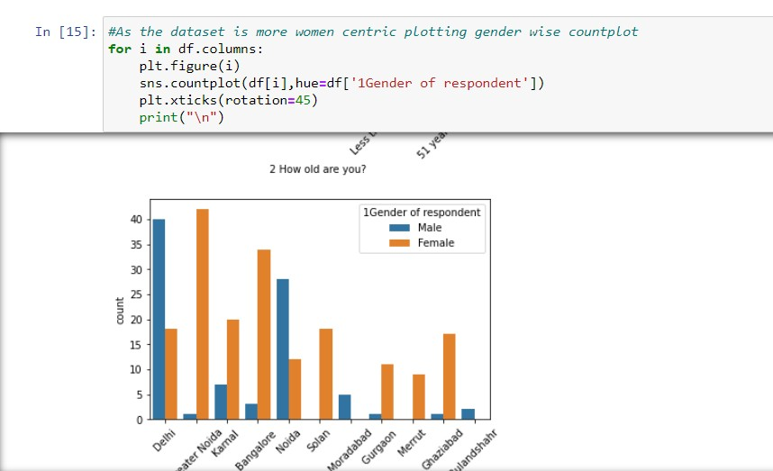Now, we will see the different plots done with this dataset in order to know the insight of the data present. Below are the codes given for the plots and the output obtained:

Below are some of the outputs obtained after running the above code:

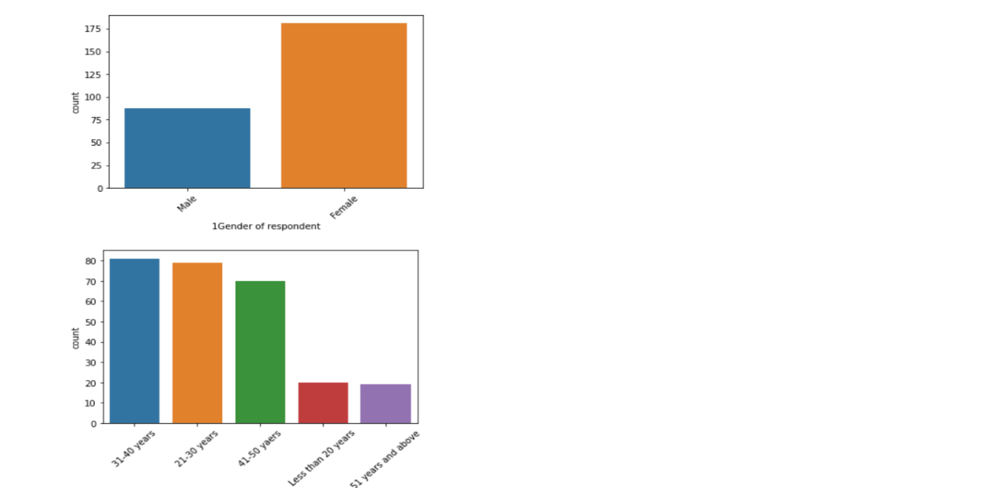

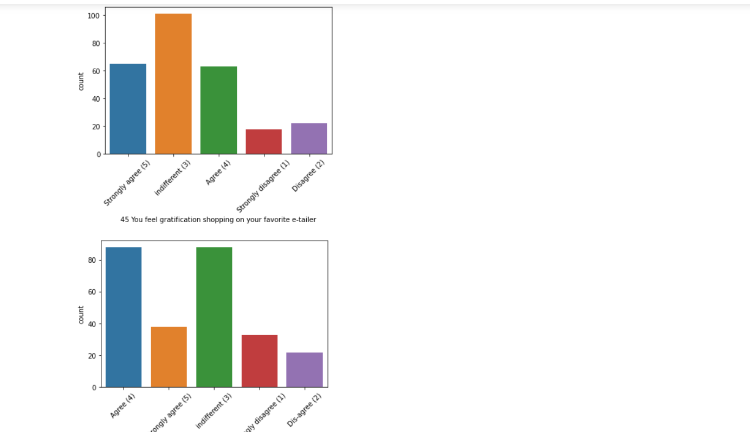

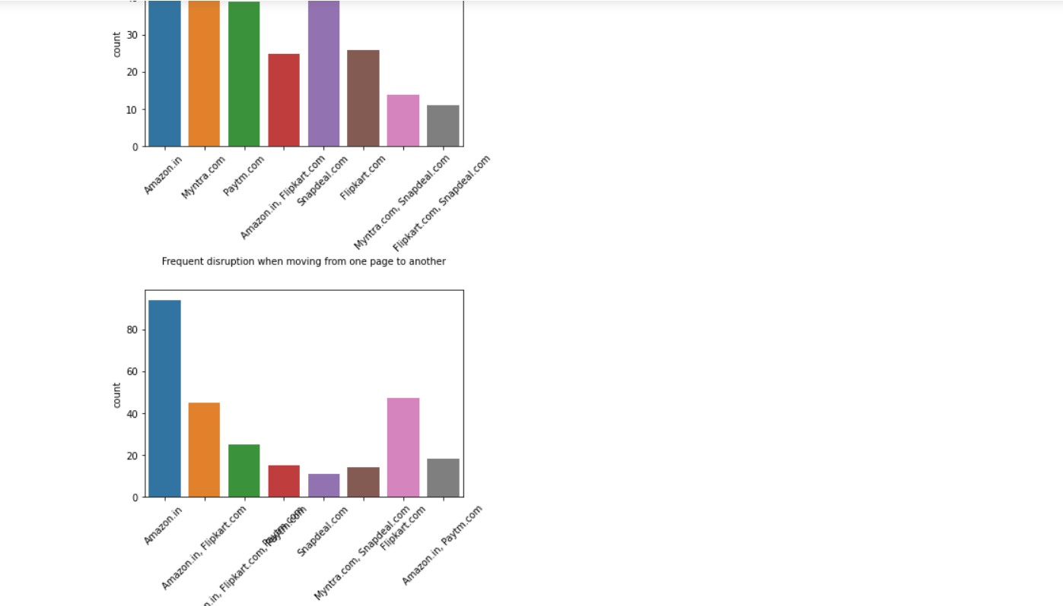

# Observations from the count plot:

1. Gender= Women are more respondents than men,may be data collection survey is mainly focused on women.
2. Age=The more respondants are 21-40 years, followed by 41-50 and less than 20 years among all the surveyee correspondents are mostly from working class.
3. Cities=Respondentsare mainly from Delhi, Greater Noida, Noida and Bangalore.
4. Vintage= Many are shopping online for more than 4 years. There are considerable no. of people who are shopping online since less than one year and also it shows that many new customers are being added every year.
5. Frequency= Many have shopped less than 10 times in the past year.
6. Gadget= Respondants use mobile more to shop online, followed by laptop, desktop and tablet.
7. System specification= Respondants use windows Operating System, followed by Android and Mac.
8. Browser= Google Chrome is majorly used to access the shopping website.
9. Prefer Ads= People are becoming customers of their favorite stores by using the search engine. Content marketing or display advertisements are not that impactful when coming to online marketing. So companies should spend more on advertising on search engines.
10. SEOs repeated visits, people use search engine first, followed by app and direct URL. We can see that difference between app and search engine is small.
11. Time Spent= More no. of the people spend more than 15 minutes before making a purchase, followed by 6-10 minutes.
12. Payment method= The major payment method used by all is credit/debit cards, followed by COD and e-wallets.
13. convergen rate= People have mentioned that sometimes they would leave the cart without purchasing and the major reason they have mentioned is that they are finding some better alternative offer. It means that people are comparing from many online websites before making any purchase.
14. User freindly= Customers strongly agree that content of website must be easy to read and understandable.
15. Product details= Most of customers want information of similar products to make purchase.Majority of the customers want complete information on listed sellers and their products being offered.

Customers want all relevant information on the listed products and very less customers disagree to that.

1. Friendly UI= The customers wanted the websites to be easily navigated.
2. Majority of the customers wanted high loading and processing speed, user friendly interface of website, convenient payment method, high trust on website, empathy towards customers, guarantee privacy of customers, responsiveness-availability of several communication channels, etc.
3. Customers feel that online shopping provides monitory benefits and discounts.
4. Customers also feel that shopping online is convenient and flexible.
5. Return policy is important for deciding the product purchase to many customers.
6. Many customers find shopping through online helps them financially because of cost and discount factors.
7. When it comes to certain factors like gratification, social status enhancement because of shopping, or whether shopping online gives a thrill or adventure, customers are more indifferent to these. So, there is an ample scope in giving more enhanced experienced to customers in this regard.

# Count plot for gender:

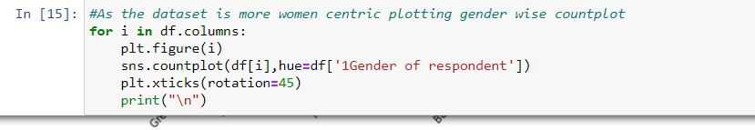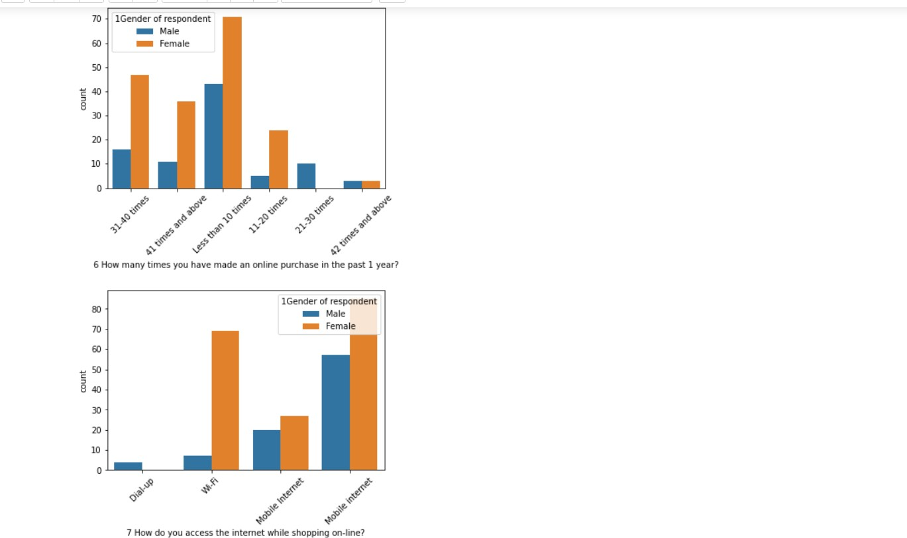

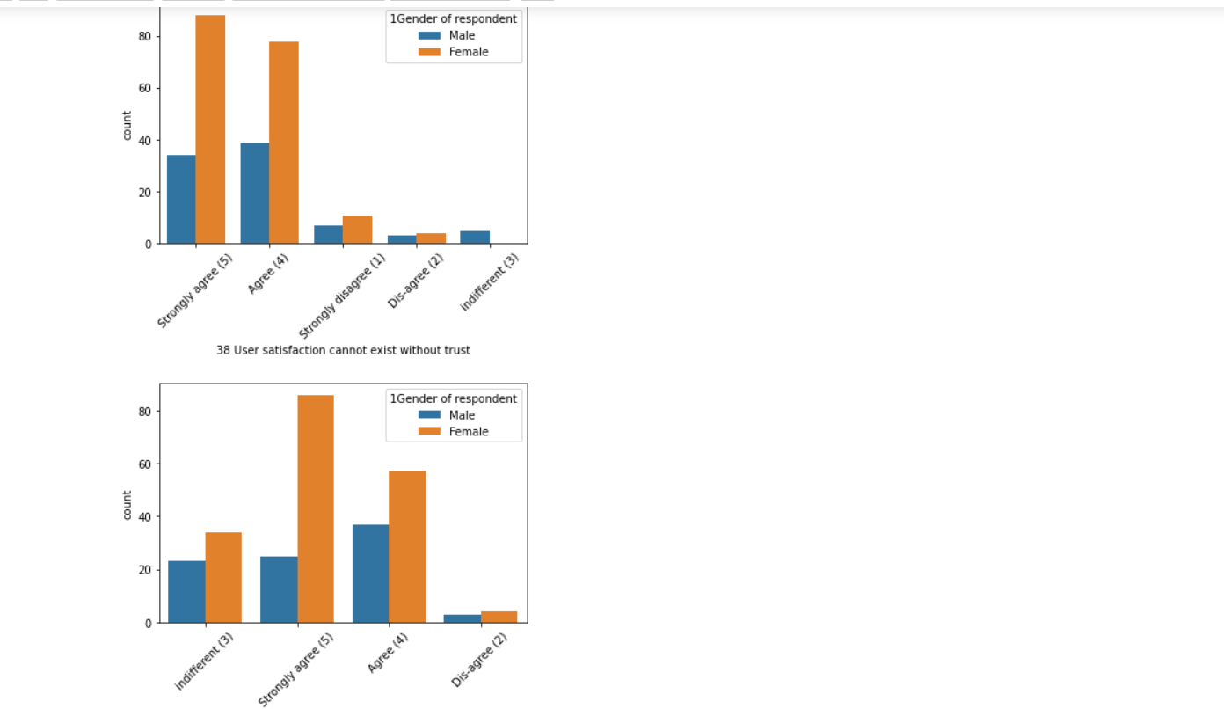

**Observations:**

* 1. Above 41-50 years and less than 20 years, female and male respondents count difference is not much.
  2. From Bangalore and Greater Noida, many respondents are female.
  3. From Noida and Delhi, many respondents are male.
  4. Both men and women shopping from desktop count are almost same. However, more women shop from either smartphone or laptop.
  5. Most of the women come back to shopping website by using search engine.
  6. Many women prefer to use search engine or app, rather than direct URL. However, men prefer to use search engine and Url and app little less. So we can understand that women use app more than men.
  7. Women spend more time than men during online shopping and
  8. Women too compare the products with other websites and is one of the reasons to leave the cart without shopping.
  9. Women prefer more loyalpoints than men.
  10. More women disagree that online shopping is a kind of adventure. So websites need to work towards giving real time experience as this can be a big marketing strategy.
  11. Women dont feel that online shopping fulfills certain roles.
  12. Rest of all other observations are similar as observed in the before countplots.

# Website vs People count:

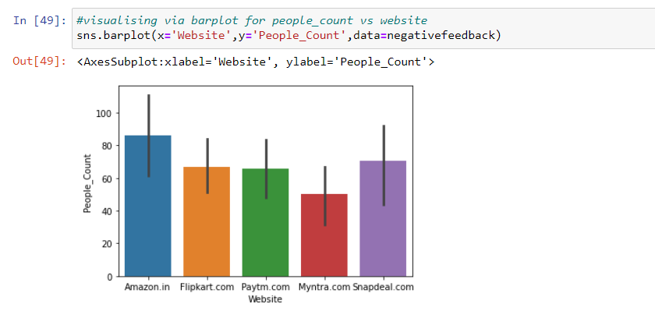

-> During the promotion time, Amazon has received more negative feedback from customers followed by Snapdeal, Flipkart and Paytm.

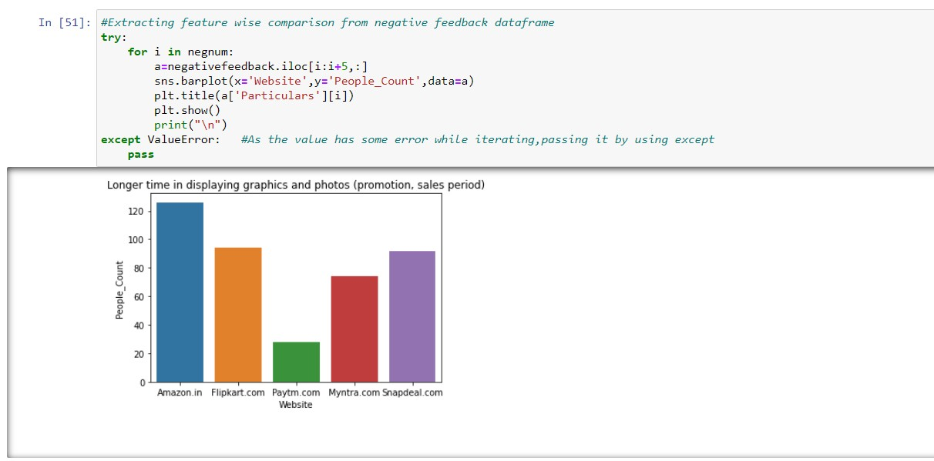-> We can note that difference between negative feedbacks of the websites is not very huge and it needs to be improved in order to handle such situations.

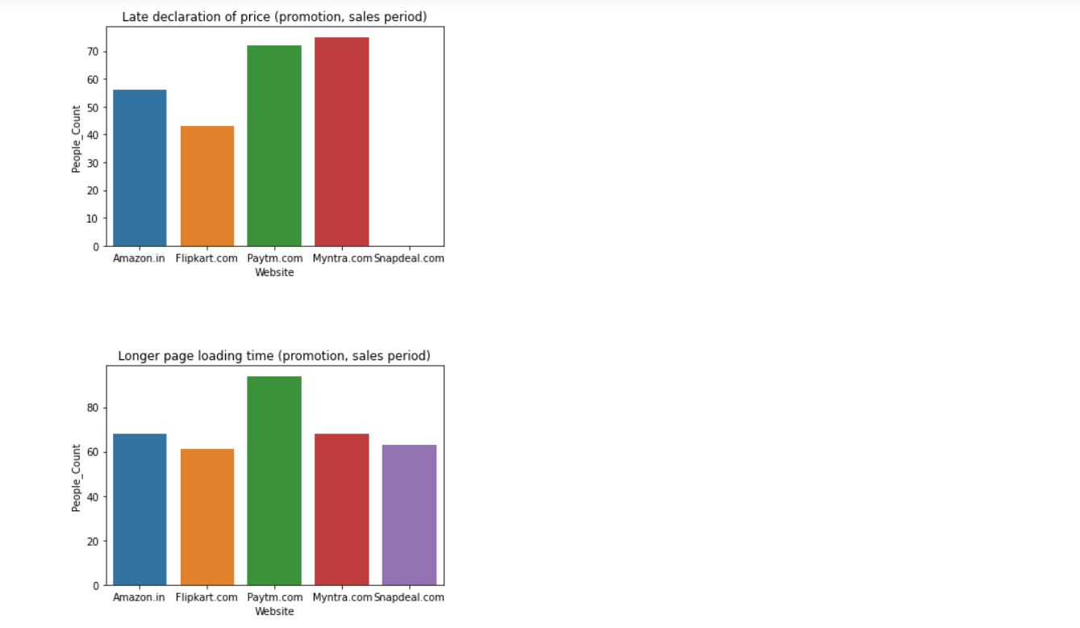

# Observations:

1. Amazon takes longer time to get logged in during promotion, followed by flipkart, Paytm and Snapdeal.
2. Amazon takes longer time in displaying graphics and photos followed by flipkart and snapdeal.com.
3. Myntra and Paytm makes late declaration of price during promotion.
4. Paytm takes longer time to load the page during promotion.
5. Snapdeal and Amazon have limited mode of payment on most of products during promotion.
6. Paytm and Snapdeal take a longer delivery period, whereas Myntra and Amazon takes lesser delivery period.
7. Amazon, Snapdeal and Myntra have frequent discrepancies, when moving from one page to another.

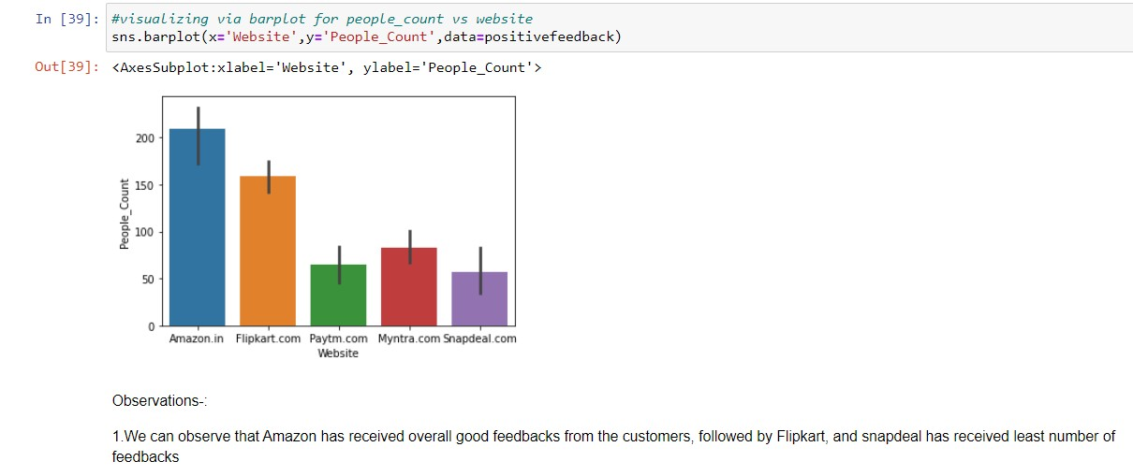

# Plotting pie-chart for website vs people count:

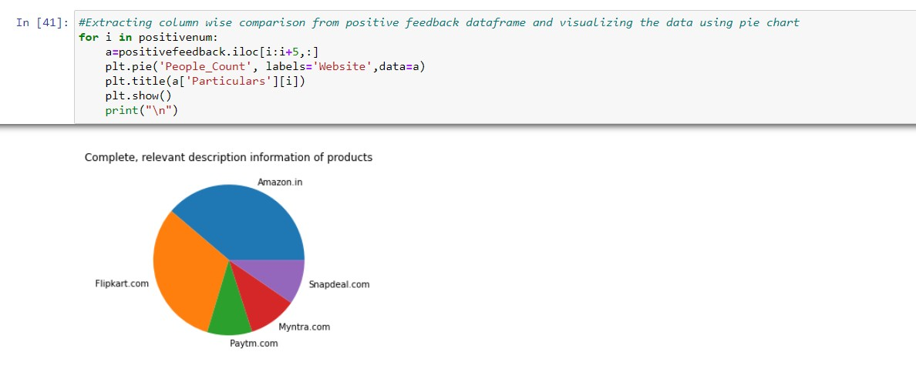

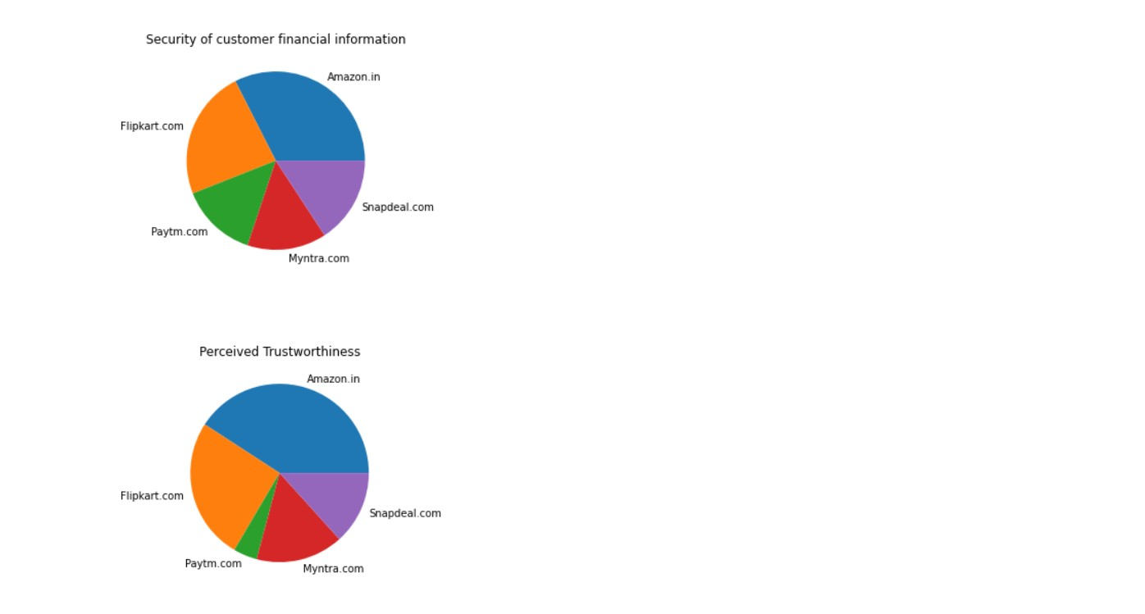

**Feature wise comparison from positive feedback data frame and plotting bar plot:**

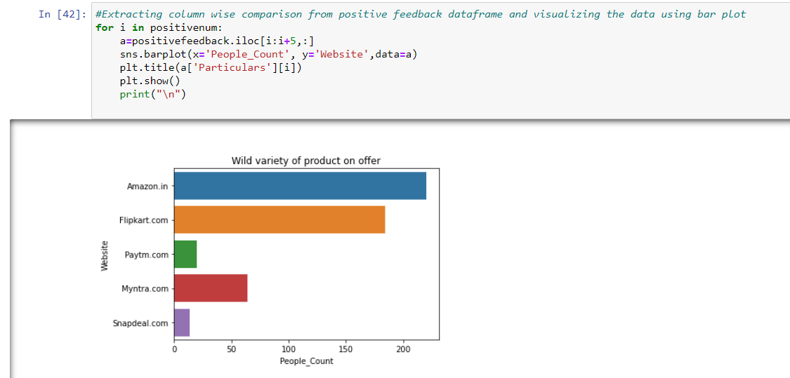

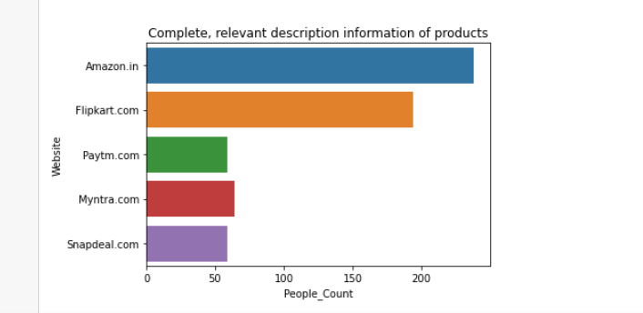

**Observations:**

1. Most customers have shopped from Amazon and Flipkart.
2. Amazon and Flipkart have been choosen most easy to use website.
3. Amazon and Flipkart have been choosen as the most visually appealing web page layout and also having wild variety of products.
4. Paytm and Snapdeal have not been given good marks on availability of wild variety of products.
5. Amazon and Flipkart have got more positive feedbacks than other websites with details to Complete relevant description and information of products, Fast

loading of websites, Reliability of website, quickness to complete purchase, availability of several payment options, speedy order delivery, privacy of customers information, security of customer financial information, etc.

1. Paytm got least feedbacks in perceived trustworthiness, presence of online assistance through multi-channel, speed order delivery.
2. Snapdeal.com has got least number of feedbacks in change of website/application des8.Myntra has got the least feedbacks in website as efficient as before, followed by Snapdeal.
3. Only one person has recommended Snapdeal.overall features.

